ENERGIZERS FOR

ORIENTATION BRAIN BREAKS

Energizers are a great way to give everyone a short break and refocus for the next few sessions. YFU Germany teaches their students many of these, so invite anyone to come forward and lead one of these during orientation breaks. Some of the energizers have links to youtube by the title, so feel free to click away and watch how much fun these can be!

Thanks so much to YFU Germany alums Amelie, Olivia and Kira for helping compile these fun energizers.

BANANA DANCE https://www.youtube.com/watch?v=1O4YF6p3kN4
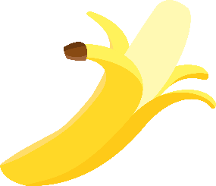
Bananas unite (place arms over head)
Bananas split (open arms and place at sides)
Peel banana, peel, peel banana (move to left)
Peel banana, peel, peel banana (move to the right)
Bananas to the left (circle arms to the left)
Bananas to the right (circle arms to the right)
Peel it down the middle and (uh) take a bite (grab and pull from out in front of you)
Go bananas, go, go bananas (do a sort of dance in a small circle, look like a fool

Form the corn
Shuck the corn, shuck shuck the corn
Pop the corn

Form the mango
Peel the mango
Do the tango

Form the orange
Peel the orange
Squeeze the orange (hug yourself)

Form the tomato
Peel the tomato
Pffft The ketchup ( pretend squeeze ketchup from bottle)

Form the carrot
Peel the carrot
Hop like a bunny ( with 2 bunny ears on top of head)

Form the avocado
Peel the avocado
Gua-ca-mole ( do a dance)

SINGING IN THE RAIN https://www.youtube.com/watch?v=xheY2FdmgJk
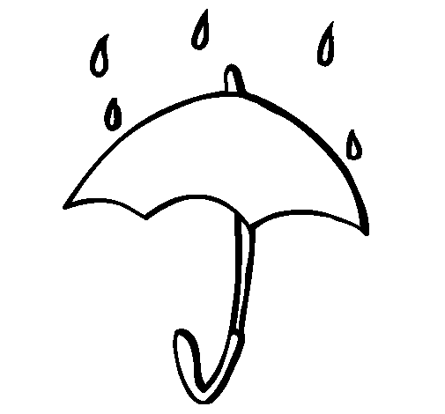
Group stands in a circle with hands on shoulders of people on each side of them. Walk in a circle and sing song. Leader calls out the action done during the chorus and group echoes with same action.

I’m singing in the rain
Just singing in the rain
What a glorious feeling
I’m happy again
Chorus:
Chubby Checker, Chubby Checker, Chubby Checker, Whoo!
Chubby Checker, Chubby Checker, Chubby Checker, Whoo!
After each verse yell out an action demonstrate that action while dancing to the chorus. Actions are cumulative
Thumbs out (echo)
Elbows in (echo)
Knees together (echo)
Butt back (echo)
Head up (echo)
Eyes crossed (echo)
Tongues out (echo)
End energizer with everyone jumping up and yelling YEA!

FUNKY CHICKEN https://www.youtube.com/watch?v=H-c5rFyTAVo
Everyone gets in a line.
I want to see your funky chicken (leader)
What’s that you say (group)
I want to see your funky chicken (leader)
What’s that you say (group)
Chorus:
Ooh ahh ahh ahh, ooh ahh ahh ahh
Ooh ahh ahh ahh, ooh, one more time
Ooh ahh ahh ahh, ooh ahh ahh ahh
Ooh ahh ahh ahh, ooh 1234
(Do actions with chorus, ie flop like a funky chicken)
Repeat verse using Crazy Monkey, Frankenstein, Superman, Ballerina, Sumo Wrestler, Surfer Dude, Egyptian…

PEANUT BUTTER

(Chorus)
Peanut, peanut butter, jelly!
Peanut, peanut butter, jelly!
First you take the peanuts and you pick 'em, you pick 'em,
You pick 'em, pick 'em, pick 'em
Then you crush 'em, crush 'em,
You crush 'em, crush 'em, crush 'em
Then you spread 'em, spread 'em,
You spread 'em, spread 'em, spread 'em...
(Chorus)
Then you take the berries and you pick 'em, you pick 'em,
You pick 'em, pick 'em, pick 'em
Then you crush 'em, crush 'em,
You crush 'em, crush 'em, crush 'em
Then you spread 'em, spread 'em,
You spread 'em, spread 'em, spread 'em...
(Chorus)
Actions:
Pick: pretend to pick berries
Crush: squish something between your hands
Spread: use one hand to spread pb/jam over other hand

THE BUTTON FACTORY SONG https://www.youtube.com/watch?v=KVHSmRcBVKM

Hey! My name is Jo
And I work in a button factory
I have a husband, three kids, and a family.
One day my boss came up to me.
He said "Jo, are you busy?"
I said,"No"
He said to "push this button with your right hand"
[make pushing motion with right hand.]
Hey! My name is Jo
And I work in a button factory
I have a husband, three kids, and a family.
One day my boss came up to me.
He said "Jo, are you busy?"
I said,"No"
He said to "push this button with your left hand
[make pushing motion with right AND left hand.]
[Continue using body parts like right foot, left foot, head, tongue, right elbow, left elbow, right knee, left knee, and bottom. End with the following]
Hey! My name is Jo
And I work in a button factory
I have a husband, three kids, and a family.
One day my boss came up to me.
He said "Jo, are you busy?"
I said,"YES!
[Slowing down] I've been working all day pushing the buttons with my right hand (stop pushing with right hand), my left hand (stop pushing with left hand), right foot (stop pushing with right foot)..."
[Continue until you've stopped "pushing"]

DOWN BY THE BAY

Did you ever go fishin’ (cast pole) on a bright summer’s day? (arms make sun over head)
Down by the bay (arms encircle bay in front of you) where the little fishies (wiggle hands back and forth) play.
With your hands in your pockets (slap hands on front pants pockets) and your pockets in your pants. (slap hands on back pants pockets)
Did you ever see the fishies (wiggle hands) do the hootchie cootchie dance?
La la la la, La la la la (index finger pointed up turn to the left in complete circle)
La la la la, La la la la (turn to the right in complete circle)
With your hands in your pockets (slap hands on front pants pockets) and your pockets in your pants. (slap hands on back pants pockets)
Did you ever see the fishies (wiggle hands) do the hootchie cootchie dance?

MRS. O’LEARY https://www.youtube.com/watch?v=hNTCtWm333Y

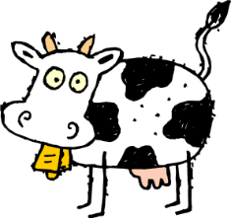
Late last night when we were all in bed
Mrs.O’Leary hung a lantern in the shed
When the cow kicked it over
She winked her eye and said:
“There’ll be a hot time in the old town tonight!”
FIRE, FIRE, FIRE
The second time you sing through this song, leave out the word “Bed” and just do the action, continue repeating song till all words are substituted for actions.
Actions:
- Bed - hold hands to one side of head as if you were sleeping.
- Lantern - hang an imaginary lantern
- Cow kicked it over - kicking motion
- Wink - wink (of course)
- Hot Night - make motions as if fanning your face
- Fire - throw hands into the air with each "fire"
CABIN IN THE WOODS https://www.youtube.com/watch?v=h_uSK3U6mk8
Little Cabin in the wood
Little old man at the window stood,
Saw a rabbit hopping by
knocking at his door.
Help me, help me, he said,
Before the huntsman shoots me dead.
Come, little rabbit, come inside,
Safely we will hide.
Actions:
cabin - draw shape of cabin in air
little old man at the window stood - hold hands up to eyes like binoculars looking out window
rabbit hopping by - hold hand in "peace" sign with two fingers extended to look like rabbit ears, and move hand from one side to the other in "hopping" motion
knocking at his door- Boom-Boom-Boom!!
help me, help me - throw arms up in air
shoots me dead - clap one hand against the other
come little rabbit - "come here" gesture with finger
happy we will be - stroke one hand with the other
Keep repeating;
with each repeat replace a line of the song with the appropriate action until no words are sung.
CAROUSEL
(This isn't really a song, but rather a noise making activity that sounds like a carousel. Split the group up into 4 separate groups and assign each a noise to make. The first noise goes first and then after a few times of making that noise, the 2nd group chimes in. Keep building with the sounds until all groups are making sounds at the same time. To end it go in reverse, taking away one group at a time until only the first group is left. After a few more Oom-pa-pa's they can finish. It really sounds cool!)
1. Oom-pa-pa
2. Oom-sss-sss
3. Oom-tiddle-dee-dee
4. Na-na-na-na-na-na-na-na-na-na-na. Na-na-na-na-na-na-na-na-na-na-na. (The tune to "The More We Get Together")
MUFFIN MAN https://www.youtube.com/watch?v=9EbtnSN_Jv4
Situation: A group of people stand in a circle. One guy starts out in the middle and he starts yelling the song to one other person he randomly picked out.
The next round these two people start of in the middle and involve two more people with the song. In the end the whole group is yelling the muffin man song.

First Verse:
Oh, do you know the muffin man,
The muffin man, the muffin man,
Oh, do you know the muffin man,
That lives on Drury Lane?
Second Verse:
Oh, yes, I know the muffin man,
The muffin man, the muffin man,
Oh, yes, I know the muffin man,
That lives on Drury Lane.
GOING ON A BEAR HUNT https://www.youtube.com/watch?v=F6OVwsnuX-Y
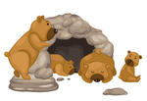
Chorus: We're going on a bear hunt.
We're going to catch a big one,
With big green eyes,
And a fuzzy little tail.
Look over there.
It's a candy factory.
Can't go over it.
Can't go under it.
Can't go around it.
Guess we'll go through it.
Yum, yum, yum, yummmm. (Chorus)
Look over there.
It's a peanut butter river. . .
Look over there.
It's a Jell-o swamp. . .
Look over there.
It's a cave. . .
It's cold in here.
I see two big green eyes,
And a fuzzy little tail.
It's a bear!
Go through the Jell-o swamp.
Swim across the peanut butter river.
Go through the candy factory.
Run home.
Open the door. Shut the door.
We went on a bear hunt,
And we weren't afraid!

