FLEX/YES 2024-25 OK to Contact List

IMPORTANT: DO NOT contact any FLEX or YES students until their country is on the list below AND their placement has been finalized for a minimum of 7 days, as not all students have been notified of their status yet.
It is crucial that all staff, volunteers, and host families understand that they must not contact any students until informed that it is okay to do so. Contact from a host family prior to notification could set off a chain reaction among the hundreds of students that applied from a given region who have not been notified.
For countries that are okay to contact, there is a mandatory 7-day waiting period after a placement has been entered in the system, before anyone may contact the student about the placement. This waiting period provides sufficient time for recruiting partners to notify the student and natural family. Note: some students live in rural areas where it may take longer to reach the student. The waiting period allows sufficient time for the recruiting partner to communicate the placement details before the student is contacted by someone in the U.S.
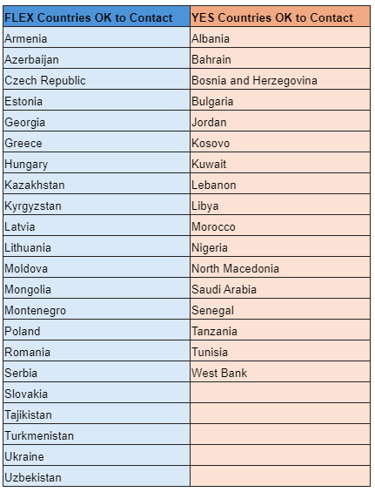
If you have any questions about this list or about when it is OK for a HF to reach out to a student, please contact Patti Sanderson or Savannah Sines.

